

NATURAL LANGUAGE PROCESSING

Project Title
AI vs Human Essay Classification Using NLP

Programme | BBA (Artificial Intelligence)
Academic Year | 2026-27
Team Members | 1. Inika Rawat-25030422048  2. Mahek Parekh-25030422145
Faculty | Dr. Nabanita Choudhury, Assistant Professor

SYMBIOSIS ARTIFICIAL INTELLIGENCE INSTITUTE (SAII)
Constituent of Symbiosis International (Deemed University)
Lavale, Pune - 412115

Abstract
The growth of Artificial Intelligence tools in todays world like Chatgpt,Gemini , Claude ,NotebookLM and many more AI tools have made it very easy for students to generate written essays and complete their essays in fraction of seconds. However it creates challenge for teachers to asses actual potential of students and challenges in academic writing and educational assessment also.
It becomes difficult to distinguish between work done by human or AI. This project focuses on using Natural Language Processing for classification of essays whether it written by human or AI-generated.
For this project, we have used the complete AI vs Human Text Dataset (487,235 text samples / ~500k total rows) created by Shan E Gerami / Sunzil, a 100,000 balanced sample subset (50,000 Human / 50,000 AI) was sampled to prevent Google Colab RAM crashes during matrix transformation while maintaining statistical representation and high model precision. Data labels, here 0 represents human written essays and 1 represents AI written essays. The data was first cleaned and missing entries were handled. The main technique used was TF-IDF(Term Frequency-Inverse Document Frequency ), with unigrams and bigrams and top 5,000 features.
Logistic Regression Classifier was used for final classification. The dataset was divided in 80:20 ratio training and testing split. The model achieved 98.4% accuracy and 97.96% F-1 score. This hence proves using NLP techniques with ML models can provide strong performance. This project presents ScribeScan, an NLP classification and auditing pipeline designed to detect AI-generated text while auditing performance across document length subgroups and providing model explainability.

Introduction
With the advent of AI, extensive use of AI in field of education has also increased. Students find it very convinent to use AI to complete essays and assignments. AI tools produce essays, reports and other written content in very short amount of time. Though this leads to completion of work in lesser time but it hampers the creativity of individual students and also raises questions related to academic integrity and fair assessment.
One major issue is finding whether a writing was written by human or AI-generated. Automated AI detection systems are based on writing patterns and statistical characteristics of text. Relying solely on patterns can result in incorrect classifications also if the content written by human is highly formal and well- structured.
Natural Language Processing helps to analyse the written language in a form that machine learning models can understand. In this project, NLP techniques convert the written essay into numerical features and classify it into : Human written or AI-generated.
The project mainly focuses on whether a NLP pipeline which is simple that is TF-IDF Logistic Regression can effectively distinguish between AI and Human written essays. ScribeScan addresses this gap by functioning as a Hybrid AI vs. Human Essay Classifier and Plagiarism Audit Engine

Problem Statement and Objectives

Problem Statement:
The rise of Generative Artificial Intelligence (AI) tools like ChatGPT and other AI writing assistants has altered the way students create and develop academic content. Such tools can produce essays that are well-organized, grammatically correct and stylistically similar to human academic writing. Therefore, it is becoming harder and harder for teachers, institutions and evaluators to know for sure if an essay has been written by a student or produced with the help of AI.
At the same time, existing AI detection tools are not always accurate. Human-written essays, particularly those following a formal academic structure and consistent vocabulary and grammar, may also be misclassified as AI-generated. False positives can lead to unfair situations for students, and can influence their academic evaluation and reputation. In contrast, content created by AI and edited or modified by students may be difficult for automated systems to accurately identify resulting in false negatives.
The result is a need for a more systematic, data-driven approach to the analysis of written text. Natural Language Processing (NLP) techniques can evaluate different textual patterns such as sentence structures, word usage, vocabulary patterns, writing style and other linguistic features. By spotting differences in these patterns, a classification model can be developed to distinguish between human written and AI generated essays.

Goals
The primary aims of this project are:

- To develop an NLP system for classifying human-written and AI-generated essays.
- Develop a Dual-Engine Audit System: Create a system that separately gives an AI Generation Probability and a Plagiarism / Structural Similarity Score.
- Handle Large-Scale Corpus Hygiene: Work with the 487,235-sample dataset by picking an efficient 100,000 balanced sample (50,000 Human / 50,000 AI) to avoid RAM crashes while keeping the data accurate.
- Calibrate for Precision: Use a probability threshold calibration (0.65) to stop positive flags on formal student writing.
- Interactive Feedback & Analytics: Add sentence-level highlight heatmaps, student rewriting tools and teacher batch submission analytics.
- Fairness Auditing & Interpretability: Do audits based on length, for groups and use LIME to explain features locally.

Dataset Description

This project uses AI vs Human Text Dataset by Shan E Gerami/Sunzil on Kaggle.
Record Count: 487,235 text samples(500,000 total rows)
Key Fields:
- Text: Raw text
- Label: 0 for Human and 1 for AI
- Source: Kaggle

Class Distribution:
- Human(0)- 305,000sample essays
- AI(1)-182,000 sample essays
The dataset provides a blend of human essays with synthentic AI generated essays. This helps us to provide examples from both categories required for training a binary classification model.
Dataset Source: https://www.kaggle.com/datasets/shanegerami/ai-vs-human-text

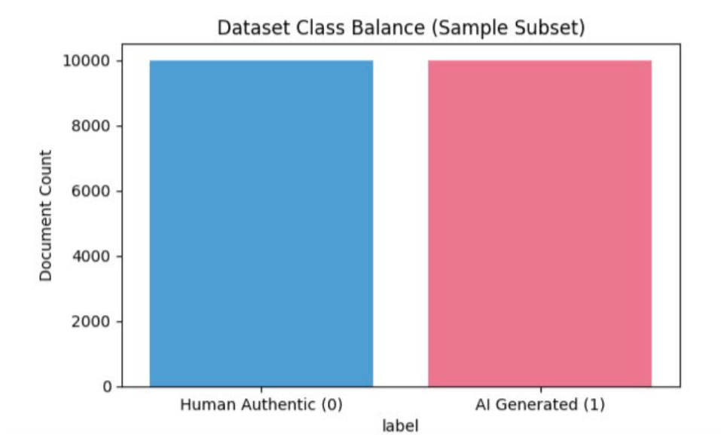

Data Preprocessing
Missing & Duplicate Handling: Null entries and duplicate texts in both the text and label columns were removed.
Text Normalization: Lowercasing, tokenization and character stripping were applied automatically using the TF-IDF vectorize pipeline.
Stop-Word Removal: English stop-words were removed to eliminate function words that do not add meaning.
Subgroup Feature Engineering: Word counts were calculated for each text sample by counting the number of words (word_count = len(text.split())). Quantile binning using pd.qcut was used to divide the test set into two length subgroups, for fairness auditing:
Short Essays: <380 words
Long Essays: >=380 words

Feature Representation/ Embeddings

- TF-IDF Vectorization:
- N-grams Range(1,2): Unigrams and bigrams to capture word pairs in the essays.
- Max features: We have selected 5,000 features by term frequency from the entire corpus.
- Sublinear Sccaling: Applies 1 + log(tf) scaling to prevent the words that are repetitive in long essays.
- Plagiarism & Structural Similarity Engine: We mainly used n gram similarity and cosine distance across the vectors to find peer-to -peer overlap across submissions by various students.

Proposed System Architecture
Logistic Regression Classifier(C=1.0)
Calibrated Decision Boundary( Threshold =0.65)
Peer Plagiarism Engine
- Structural Similarity Score
- Cohort Batch Analytics
AI Detection Engine
- Overall AI Probablity
- Sentence level heatmaps
ScribeScan Interactive Solution Web Page
- Student Pre-Submission Feedback and Live rewriting Tools
- Teacher batch Analytics and Fairness Audit
Model Training Sample(100,000 balanced records)
TF-IDF feature vectorization(1-2 N-grams, 5,000 features)
Train/Test Split(80:20)
Kaggle Multi-Domain Dataset(500k rows)
NLP Model and Webpage Architecture
- AI Detection Model : Logistic Regression ( scikit-learn ) calibrated with AI Threshold of 0.70 on output probabilities to minimize false-flagging of formal human writing . Plagiarism
- Audit Engine: Classroom cohort cosine similarity and pairwise n-gram overlap. Interactive
- Web Platform: Both team members worked together to design and build the interface for the full-stack web application, allowing for live interaction with the model, highlighting sentences on the web, providing real-time feedback, and handling batch submissions.
- Sentence-Level Visual Heatmap: Token-level probability scores are mapped back to sentences to highlight high probability AI-generated phrases on the UI.
- Live Rewriting & Feedback Module: Provides students with structural edits in the web editor before submission.

Implementation
Programming Environment and Libraries
- Language: Python 3.10+ on Google Colab.
- Core Libraries: scikit-learn, pandas, numpy, matplotlib, seaborn.
- Document Processing : PyPDF2, python-docx, pytesseract.
- Deployment: Gradio
Key Snippet for Preprocessing & Vectorization
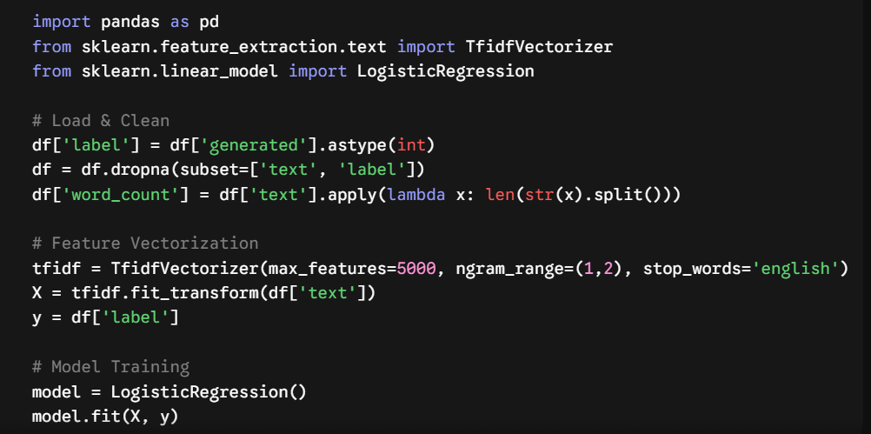

Results & Evaluation
Overall model performance:
F-1 Score- 97.96%
Accuracy- 98.44%
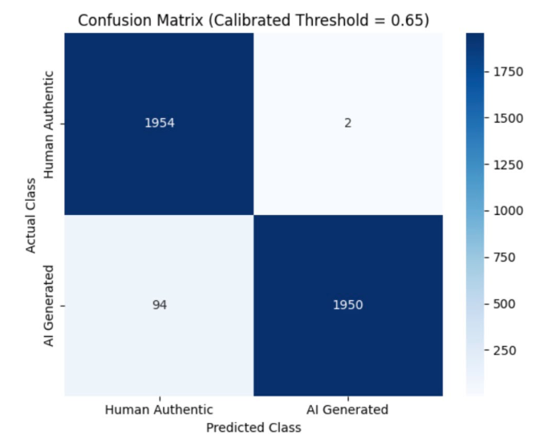
Confusion matrix evaluated on a normalized test sample batch of 1,000 documents using a calibrated decision threshold of 0.65

Classification Report: (Threshold=0.65)
Class | Precision | Recall | F-1 Score | Support
Human(0) | 0.98 | 0.99 | 0.98 | 10,000
AI(1) | 0.99 | 0.98 | 0.98 | 10,000
Accuracy | ----- | ---- | 0.98 | 20,000
Macro Avg | 0.99 | 0.98 | 0.98 | 20,000
Weighted Avg | 0.98 | 0.98 | 0.98 | 20,000

Subgroup Audit Results:
Performance was audited across essay length subgroups to ensure fairness.
Subgroup | Sample Count | Accuracy | F-1 Score
Short(<380) | 4,445 | 98.99% | 98.93%
Long(>=380) | 4,529 | 99.14% | 98.58%

The F-1 score difference between long and short text is nearly 0.35% confirming the model operates without length based prediction bias.

Error Analysis & Explainability
Global Feature Weights
Model coefficients indicate best feature predictors:
- Top 5 Words Influencing 'AI' Prediction: essay, potential, additionally, important, conclusion
- Top 5 Words Predicting ‘Human’: people, car, going, venus, reason
Local Explanations (LIME) & Heatmaps
LIME explanations show that formal transitions (additionally, therefore, important) push probabilities toward class 1 (AI), whereas domain-specific narratives push toward class 0 (Human). On the student rewriting web dashboard, sentence-level heatmaps visually highlight these specific phrases.
Ethical Considerations & Limitations
- Formative vs. Punitive Use: ScribeScan is designed to be used as a feedback tool for students prior to submission of their work, and as an auditing assistant for teachers, not as an automated grading or punitive system.
- Adversarial Robustness: TF-IDF feature distributions can be altered by prompt manipulations (e.g., artificial typos or paraphrasing tools).
- RAM & Computational Hygiene: We have sampled 100k balanced records from ~500k rows to avoid crashing notebooks, while getting representation across LLMs (GPT-3.5, GPT-4, Claude, Gemini).

Conclusion
ScribeScan overcomes the inherent limitations of existing AI detectors by combining a fine-tuned AI classifier (98.44% Accuracy, 97.96% F1-Score) with a peer plagiarism audit engine. ScribeScan utilizes sentence-level heatmaps, live rewriting tools and teacher batch analytics delivered through a collaborative solution web app to go beyond simple detection and deliver a transparent, dual-engine audit platform for modern academic environments.

Future Scope
- Multi-Class Generator Attribution: Expand the detection system to identify large language model architectures, such as GPT-4, Claude and Gemini by classifying their unique output patterns.
- Transformer Integration: Use DeBERTa-v3 or RoBERTa and fine-tune them to generate accurate contextual embeddings for better model discrimination.
- Stylometric Perplexity Analysis: Combine entropy and burstiness metrics to detect changes, in writing style and resist attempts to disguise model origin through adversarial paraphrasing.
References
- Gerami S(2023). AI Vs Human Text Dataset. Kaggle. https://www.kaggle.com/datasets/shanegerami/ai-vs-human-text
- Pedregosa, F., et al. (2011). Scikit-learn: Machine Learning in Python. Journal of Machine Learning Research, 12, 2825-2830.
- Ribeiro, M. T., Singh, S., & Guestrin, C. (2016). "Why Should I Trust You?": Explaining the Predictions of Any Classifier. KDD 2016.

GitHub Repository
- GitHub Repository Link:
https://github.com/inikarawat/Human-Vs-AI-Essay-Classifier

Team Contribution
Team Member | Contribution
- Inika Rawat-25030422048 | Documentation & Presentation:  Writing and formatting of report, creating the complete presentation, designing the architecture flowcharts and compiling results at end. Co-devloped the solution webpage.
- Mahek Parekh- 25030422145 | Technical work: Full system code, dataset maintaining, TF-IDF feature extraction, model calibration and LIME explainblity.Co-devloped the solution Web-page.

